**Academic English Guide**

Phase #2 – From March 26th to April 3rd.

**Student:** Julio José Vargas Hernández **Grade:** 11th. Grade **English Level:** C4

**GENERAL INSTRUCTIONS**

* The assigned work will be divided into the four language areas that we exercise on a regular basis in class (Listening, Reading, Writing & Grammar). Every language area will have an assigned grade and a specific rubric for its revision.
* The objective is to exercise them throughout the week and deliver the final product to the latest on **April 3rd** by email to the following address:

[nivelmedio-ingleszacapa@colegioverbo.edu.gt](mailto:---------@colegioverbo.edu.gt)

* Save your document like this: **Student´s name­_10th Grade_English Guide**
* This guide must be presented identified with name, grade and level the student belongs to.
* If necessary, insert text boxes in order to identify and fulfill your work.
* Remember to apply the appropriate use of grammar, spelling, punctuation and capitalization rules in each activity you do.

|  |  |
| --- | --- |
| **Contents** | **Christian Philosophy** |
| * Vocabulary Builder * Reading about “Biggest cities” * Article * Future tenses | * **Bible Principle:** Christian Character * **Bible verse:** Genesis 24:11 * **Value:** Loyalty |

**VOCABULARY AND LISTENING**

**Instructions:** Watch out the chart below, then search the definitions of the words in the internet and write them down.

|  |  |
| --- | --- |
| Widowed | Lose one's spouse through death. |
| Childhood | The state of being a child. |
| Engagement | A formal agreement to get married. |
| Marriage | The legally or formally recognized union of two people as partners in a personal relationship |
| Spoiled | A person, especially a child harmed in character by being treated too leniently or indulgently. |
| Shrine | A place regarded as holy because of its associations with a divinity or a sacred person or relic, marked by a building or other construction. |
| Abduct | Take someone away illegally by force or deception. |
| Measure | Ascertain the size, amount, or degree of something by using an instrument or device marked in standard units or by comparing it with an object of known size. |

**Instructions:** Choose 5 words from the list and do the following:

1. 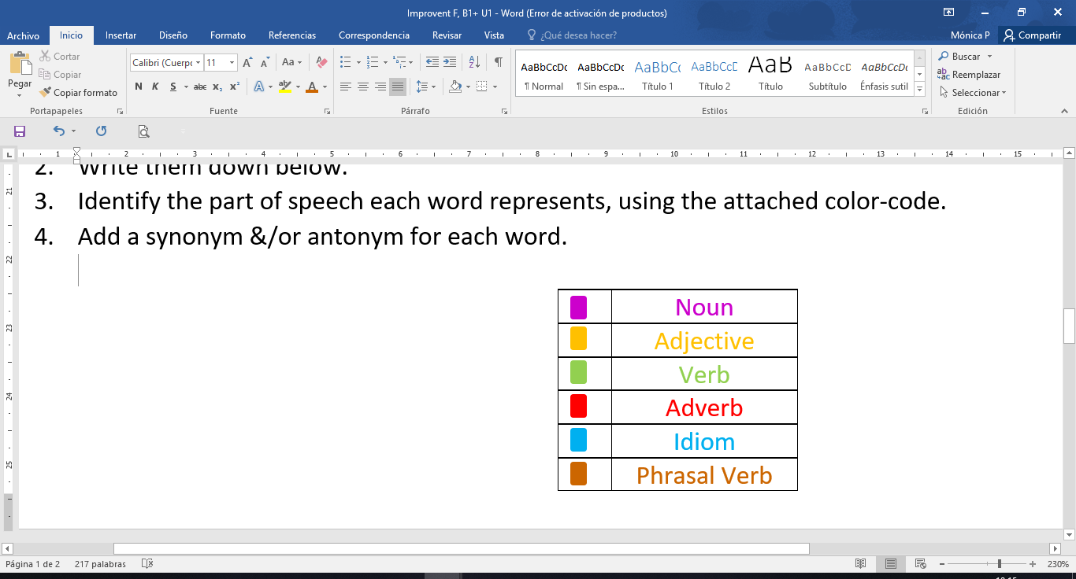List words in alphabetical order.
2. Identify the part of speech each word represents by using the attached color-code.
3. Add a synonym for each word.
4. Write one sentence applying each word.
5. **Childhood,** Babyhood.
6. **Engagement**,Commitment.
7. **Marriage**, Matrimony.
8. **Spoiled**, imp, rotten.
9. **Widowed**, Single.
10. Her Childhood was what anybody could ever dream to have.
11. Sofia and Alex got engagement.
12. He got marriage with the love of his life.
13. She born with wealthy and not very strict parents, that's why she is a spoiled brat.
14. The widowed lost her husband last month, she is still depressed

|  |  |  |  |
| --- | --- | --- | --- |
| **Criteria** | **Evidence** | **No Evidence** | **Observations** |
| Lists the required words in alphabetical order. |  |  |  |
| Appropriately identifies the parts of speech by using the given color code. |  |  |  |
| Writes a synonym and antonym for each word. |  |  |  |
| Appropriately use of grammar and spelling. |  |  |  |
| Presents an example for each word through meaningful images. |  |  |  |
| **Total** | **/** | | |

**Vocabulary Checklist**

**READING**

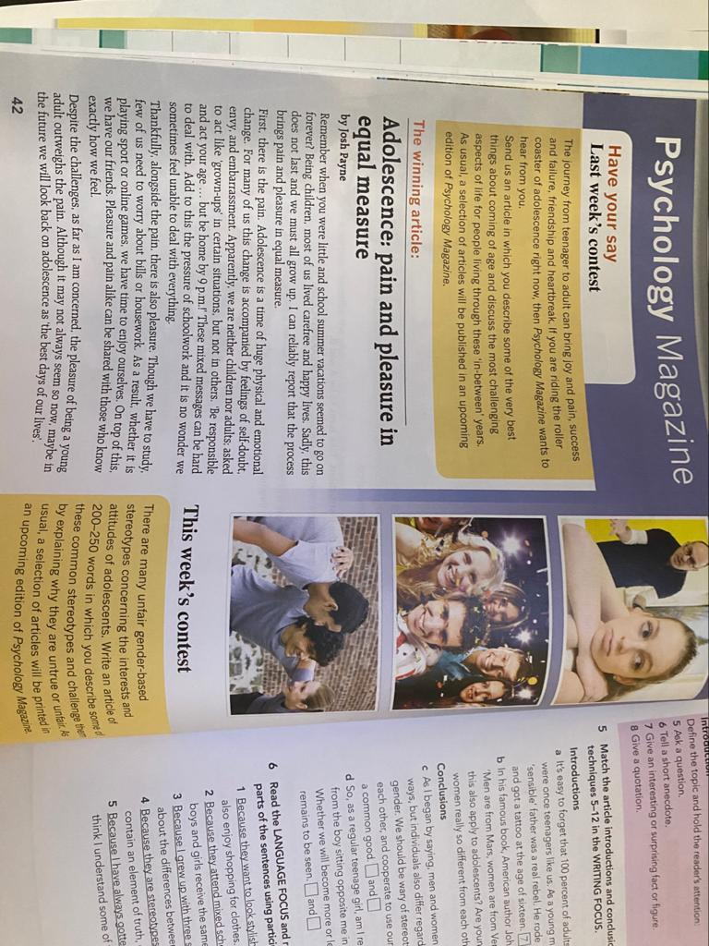**Instructions:** Read the text and complete the tips for writing an article with the words in the box.

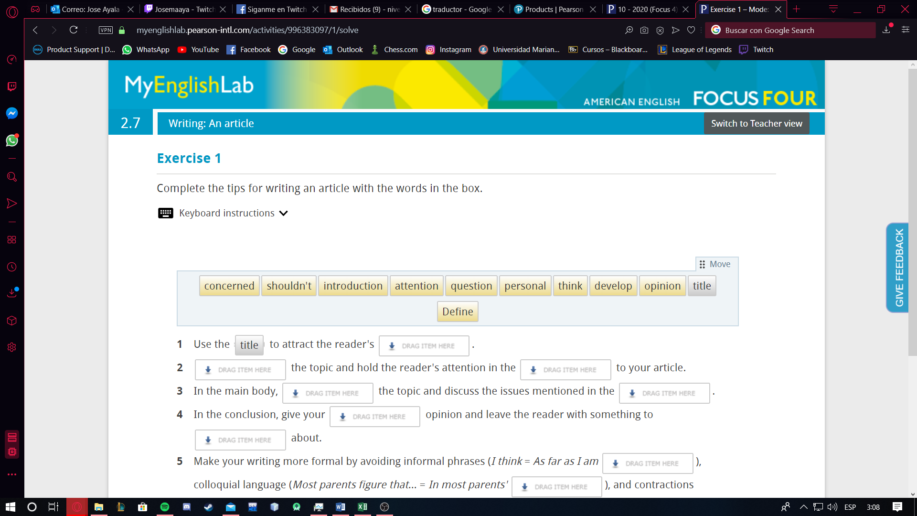

1. ****Use the ***TITLE*** to attract the reader's ________________.
2. ****________________ the topic and hold the reader's attention in the ________________ to your article.
3. ****In the main body, ________________ the topic and discuss the issues mentioned in the ________________.
4. ****In the conclusion, give your ________________ opinion and leave the reader with something to ________________ about.
5. ****Make your writing more formal by avoiding informal phrases (I think = As far as I am ________________), colloquial language (Most parents figure that… = In most parents' ________________), and contractions (________________= should not).

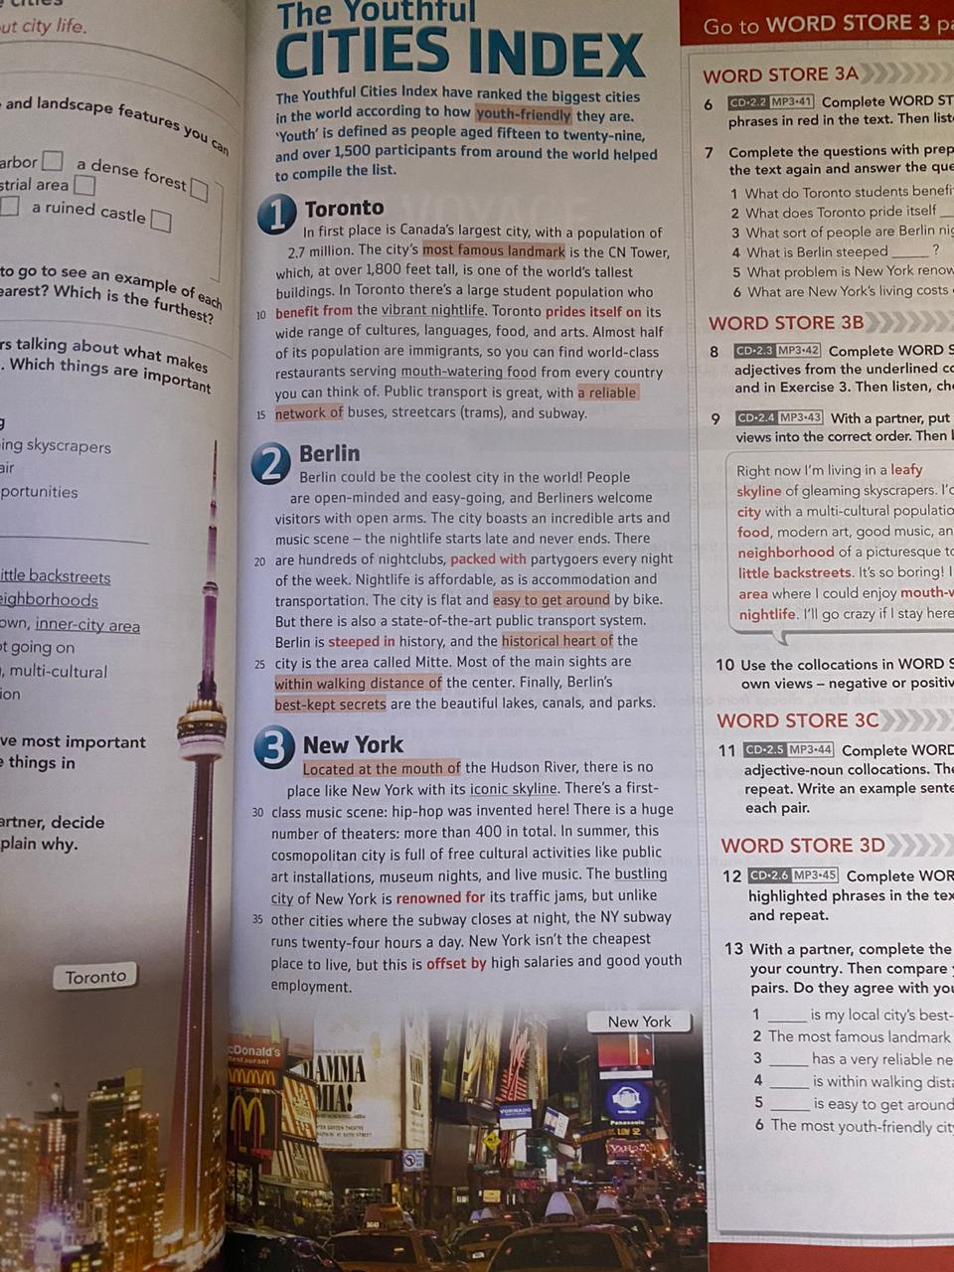

**Instructions:** Read the lecture “The Youthful Cities Index” and complete a graphic organizer with the biggest cities in the world (write the title in the middle example “TOP 5 BIGGEST CITIES)

* Include name
* Include population
* Include country

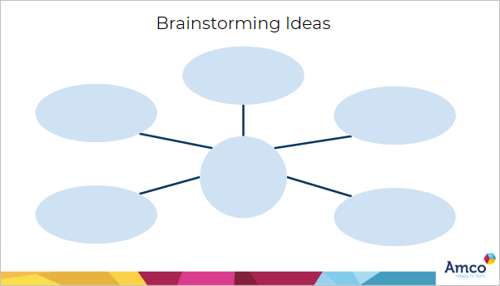

Berlin:

* Capital of German
* 3.77 million habitants

New York:

* Population: 8.62 million
* Touristic attraction of the USA.

Toronto:

* Population: 2.7 million.
* Canada’s largest city.

**Most**

**youth- friendly cities**

Characteristics

* Touristic destinations with culture acceptance.
* Habitants with an “open mind”

More characteristics:

* Easy access to public transportation.
* Active nightlife.

**WRITING**

**Instructions:** Read the task below. Before you start writing, note down some ideas and plan your piece of writing. Then write an article. Include at least one sentence with a participle clause.  
  
Write an article of 140–190 words for your school's website. Describe the beginning of the friendship with your best friend and explain the role of friendship for young people as they grow up.

**Is there something that really lasts forever?**

Well, the answer is way simpler that you think, no. But that is how life works, not even you nor the universe itself will last forever, it is not something to be disappointed about. The concept of “Friendship” is subjective and ambiguous, it is a different experience for everybody, just like love; as humans, we are used to have different perceptions of the same thing, because of our feelings and our worldview.

Also the idea to choose a friend over another, is not an easy decision most of the time; nevertheless, I do actually believe I have a bestie, her name is Carla Ruiz, I am pretty sure you may know her; if you don’t, you definitely should. We meet last year at verbo school, she is one of my classmates, things just happened naturally because both of us have similar interests and enjoy laughing and messing around. But most importantly we deal with some secrets or annoying characteristics of the other that most do not.

In my case, I have had many “best friends” that I have not hear about in years; I would also like to point out that my marvelous couple Juliana Guzmán, more than my girlfriend is my best friend, confident, family, partner in crime and time, someone who I trust and spend more time with than anybody else. Fun fact: Blown by the hair-dryer, her hair could easily be cut (Just kidding).

Having someone to trust other than family or your couple is specifically important and healthy at this stage of life, in order to help you and be alongside you on multiple situations, (not only the bad ones), even though is even more important to trust and love your family overall; relationships sadly, usually have an end, I always got the philosophy to don’t overthink about the end of the journey, just enjoy it till it last.

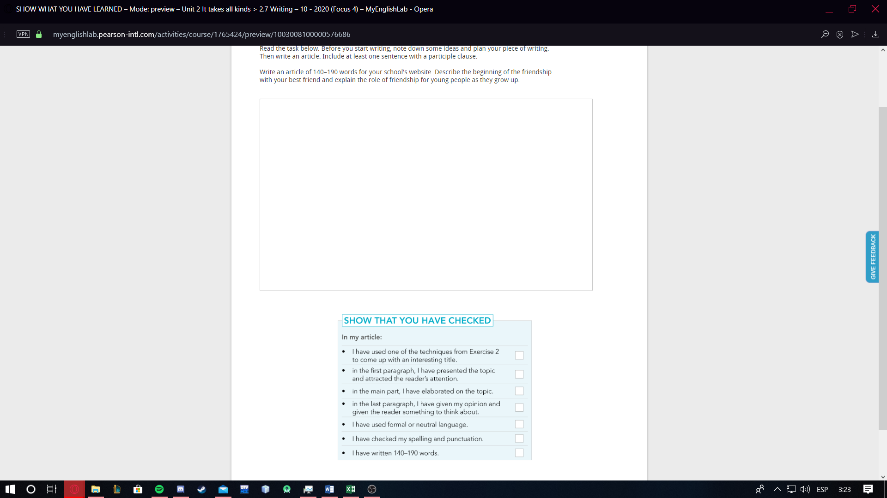

Pardon me.

* **Instructions:** Watch the following video in YouTube through this link: <https://youtu.be/SOCixRhRGDw>

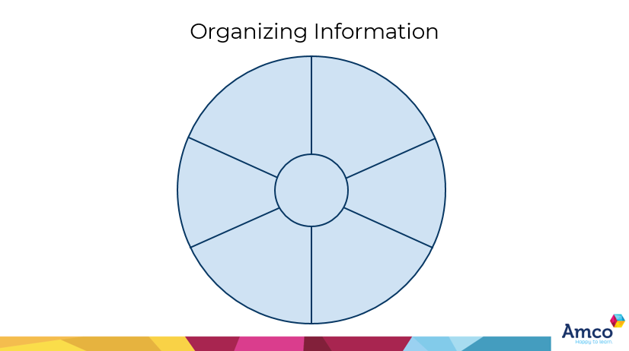 Then create a graphic organizer with the most important information that is in the video

Water is only used for drinking purposes.

The astronauts use a robot arm in order to fix things on the outside of the station.

The muscles of the astronauts of the I.S.S get weaker because of the absence of gravity

Astronauts do not use normal water in order to take a shower.

It is powered by solar panels.

It is a space station destined to do scientific research.

**The I.S.S**

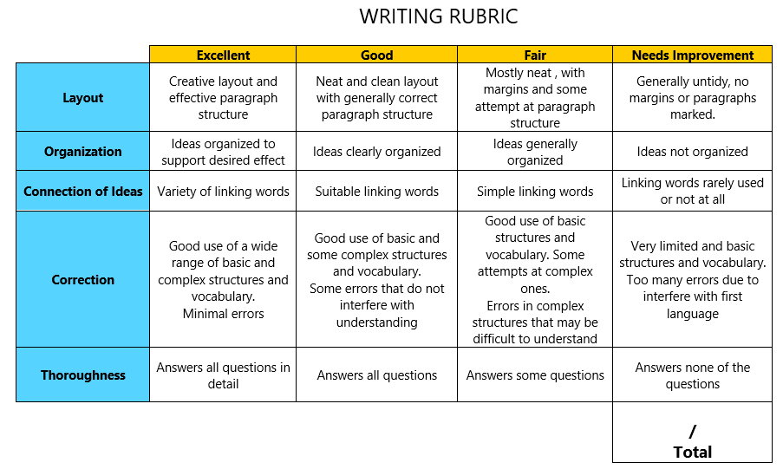

**GRAMMAR**

**Instructions:**

* Watch the following video in YouTube through this link to learn about future perfect: <https://www.youtube.com/watch?v=rcxytsa8CbI>
* Watch the following video in YouTube through this link to learn about future perfect progressive: <https://youtu.be/HPz_5NXh91E>
* Watch the following video in YouTube through this link to learn about future progressive: <https://youtu.be/GxMy-7-IbGs>
* Then, create a comparative chart between the three uses including, rules/use, structures and examples

|  |  |  |  |
| --- | --- | --- | --- |
| INCLUDING | FUTURE PROGRESSIVE | FUTURE PERFECT | FUTURE PERFECT PROGRESSIVE |
| RULES/USE:  STRUCTURES:  +  -  ?  EXAMPLES  +  +    -  -  ?  ? | It is used for actions that will be happening at a certain time in the future  For actions that will be happening at the same time in the future.   * S+Will+Be+Verb in preset participle. * S+Be going to+ Be+ Verb in present participle. * S+Will not+Verb in present participle. * S+Am/Is/Are Not+Going to+ Be+ Verb in present participle. * Will+S+Be+Verb in present participle. * Am/Is/Are+S+Going to+Be+Verb in present participle. * I will be running at eighth o clock. * He is going to watch a movie tomorrow. * I will not allow you to talk to her like that! * She is not going to go to the party. * Are they going to go to the concert? * Will it be raining while we are at Samantha’s house? | Refers to an action that will happen before another action in the future.   * S+Will/Be Going to + Have+ Verb in past particple * S+Will not/Won’t+ Have+Verb in past particple. * Will+S+Have+Verb in past participle * By the time I finish all my homework, The outbreak will be over. * They are going to have died of insanity before the outbreak is over.      * Her boyfriend will not have ate his food before she does * I am not goint to have finised reading before we leave for lunch. * Will their teaher r have checked their homework before they come back to school? * Is he going to have completed the game before I ask him to go out with me? | Used to show that an action will continue up until certain period of time or event in the future.   * S+Will+Have been+Verb in present participle. * S+Be going to+Have been+verb in present participle. * S+Will not+ Have Been+Verb in present participle. * S+Am/Is/Are Not+ Going to+ Hve Been+Verb in present participle. * Will+S+Have Been+Verb in present participle. * Am/Is/Are+S+Going to+ Have Been+Verb in present participle. * She will have been sleeping by the time I arrive home. * He is going to have been eating on Italy by the time he finds out about the COVID-19. * I will not have been dying of starvation waiting for you. * Their daughter is not going to have been doing homework while they are not watching her. * Will his Giraffe have been dying of depression by the time he comes back. * Am I going to have been dying of oldness waiting for you. |

